<https://deeh4.github.io/>

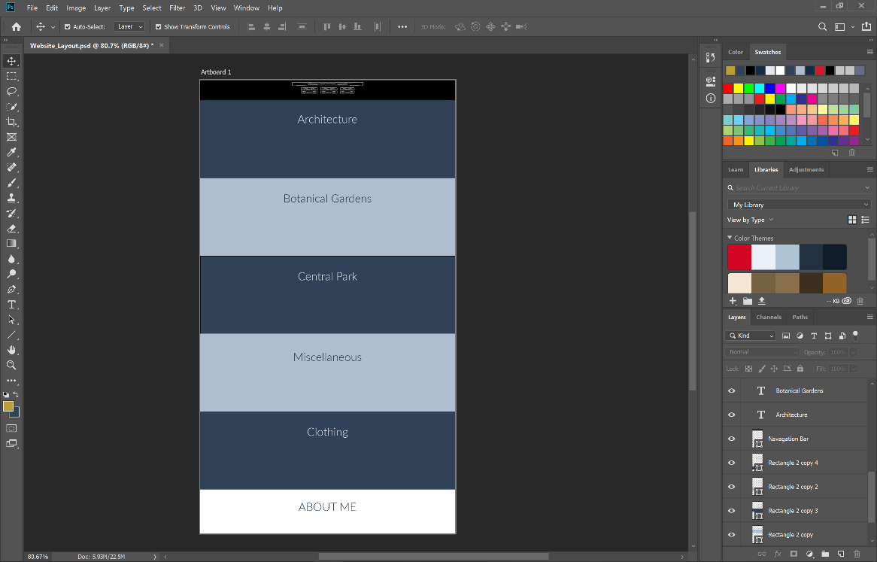My website is one that has six pages/sections on a single continuous page and will feature jump links that take you to each page/section.

The content of the site is the photos that I have taken for projects in high school and University, each section will feature a lightbox that allows the viewers to click on a thumbnail in which it expands into a higher resolution version of the photograph.

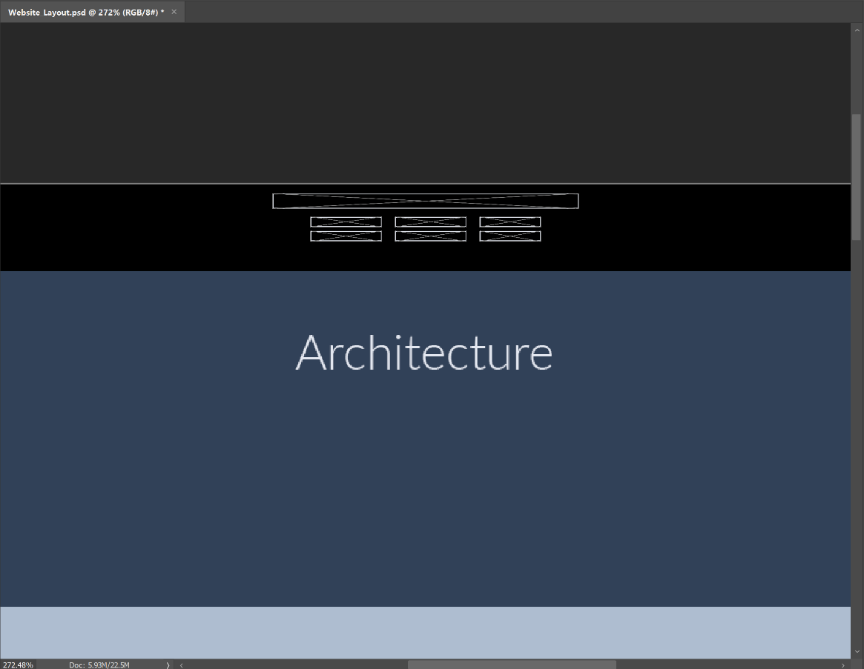

The navigation bar will have links that jump to each section of the page, I wanted to make it a simple design by naming it after each section on the page and by also stacking the links to make it a clean layout.

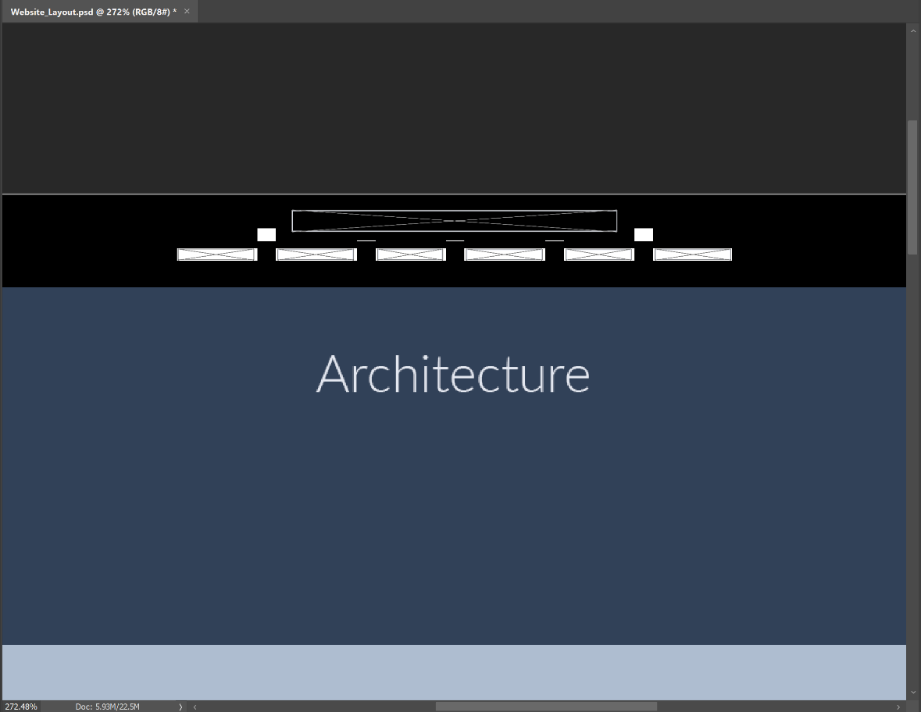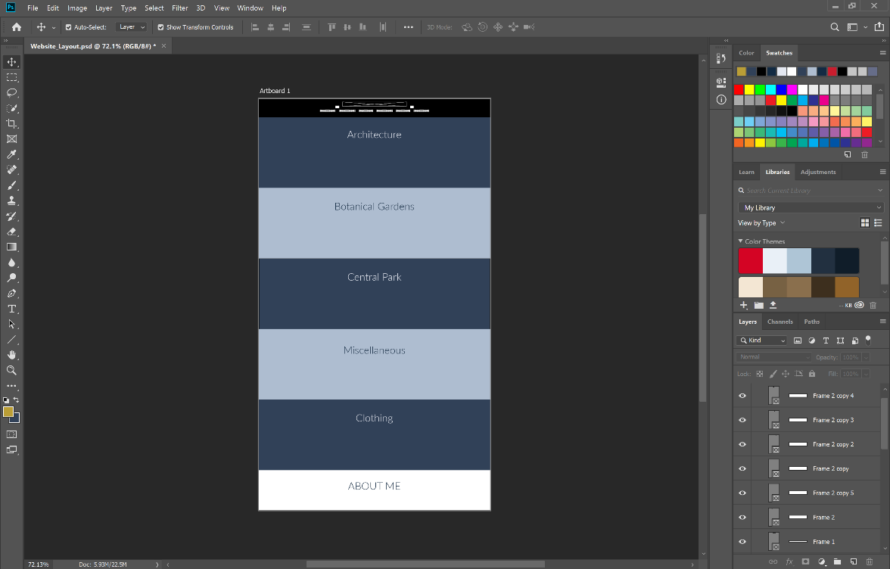This is a slightly altered layout in which I change the positioning of the links in the navigation bar, after I tried the first layout I found that the links on the bottom were not able to be in the position that I wanted them to be in even though they were both centred aligned, the positioning of the words made it look tacky, therefore I decided to move the links onto a single line on the navigation bar, still resulting in the clean look that I wanted the first layout to achieve.

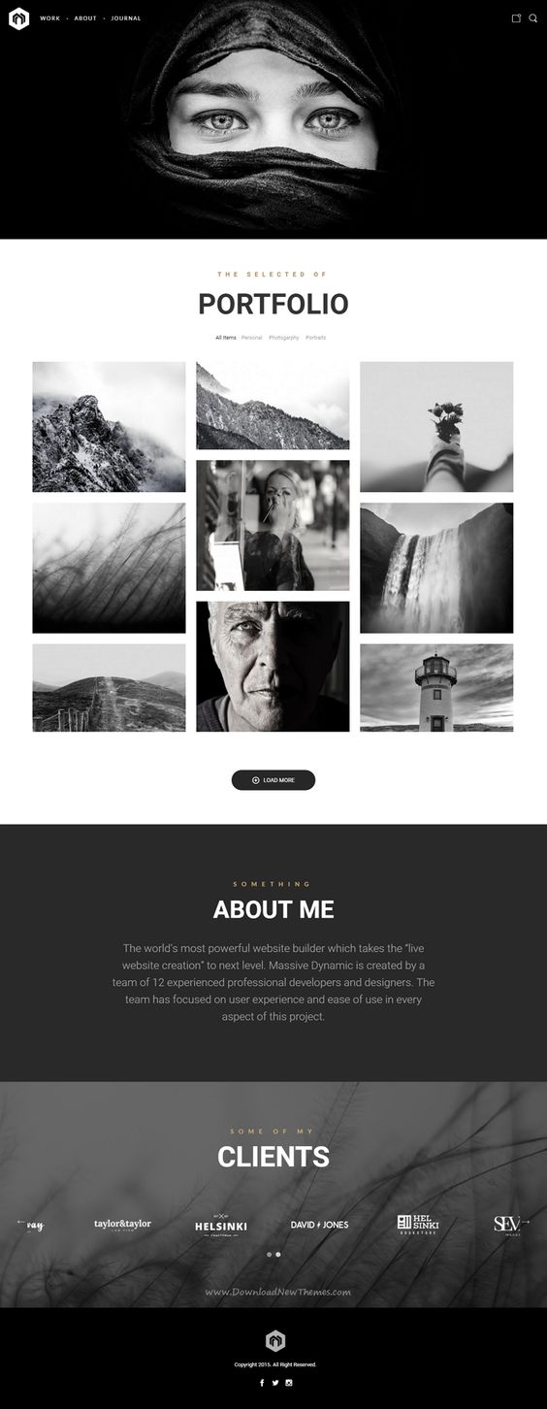

Figure 1. Massive Dynamic - WordPress Website Builder - <https://www.pinterest.nz/pin/AaR5e89DmrG7BoisCcwvvNmT0L-hOjZzLrOfOxNRR403gA0P6j6TMPw/>

I was browsing through pinterest to search for inspiration for the layout of my portfolio website and found this photo of someone’s portfolio website that that they created by using a wordpress website builder. The reason why I chose this example was because it has the lightbox javascript that allows the viewers of the website to click on thumbnails in which it will bring up a higher resolution version, as well as it being a single page with jump links to each section of the page.

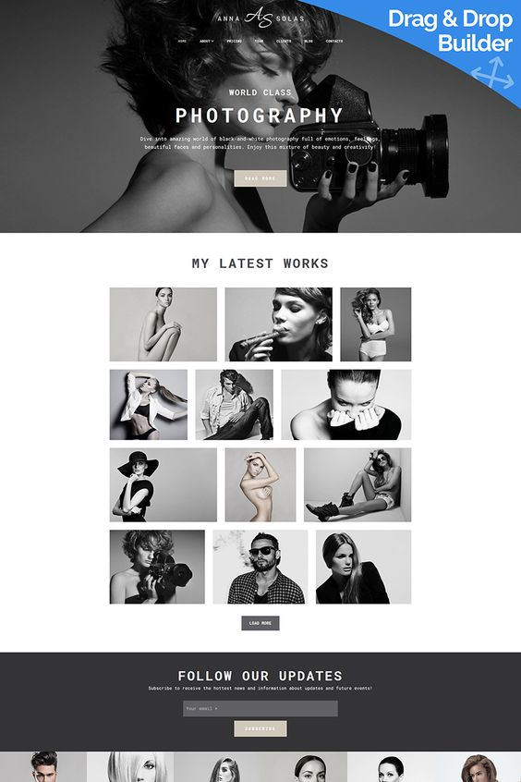

Figure 2. Anna Solas - Photographers Portfolio Photo Gallery Moto CMS 3 Template - <https://www.pinterest.nz/pin/353251164516472632/>

This is the second example that I found of a website layout based of a service that allows people to build a website by using their template, this example has a simple and clean design that I wanted my portfolio website to have, especially in the navigation bar which is a simple layout with their logo/name at the top of the page with links running across the bottom in a single line, this inspired me to change the way my links were positioned in the navigation bar.